**PlantPalette - A Fruit and Vegetable Prediction using**

**Deep Neural Networks**

**SOWMIYA S , SREENA R**

**Rajalakshmi Engineering College**

**Thandalam, Chennai**

**Abstract:**

In recent years, deep learning techniques, particularly Convolutional Neural Networks (CNNs), have authenticated exceptional capabilities in various fields, including image recognition, natural language processing, and medical diagnosis. In this study, we propose a CNN-based approach for predicting fruits and vegetables. Leveraging CNN's hierarchical feature learning, the model achieves accurate classification of distinct produce from input images. Preprocessed datasets ensure regularity, while the architecture includes convolutional and max-pooling layers for feature extraction. Dropout regularization prevents overfitting, and batch normalization accelerates convergence. Experimental results demonstrate superior accuracy compared to traditional methods, promising applications in agricultural automation and food quality inspection.

**Keywords:**

Fruit and Vegetable Prediction, Image Recognition, Convolutional Neural Network(CNN), Computer Vision, Deep Learning, Feature Extraction, Fruit and Vegetable Classification.

**Introduction:**

This study addresses a Convolutional Neural Network (CNN) approach for predicting fruits and vegetables. In this study, we come up with a CNN-based approach for predicting fruits and vegetables. The proposed model leverages the hierarchical feature learning ability of CNNs to spontaneously extract discriminative features from raw input images, enabling accurate classification of dissimilar fruits and vegetables.

The dataset used in this study is composed of images with various fruits and vegetables collected from diverse sources. These images are preprocessed to ensure uniformity in size, color, and strong matches. The CNN model architecture consists of multiple convolutional layers followed by max-pooling layers to extract spatial hierarchies of features and reduce dimensionality. Dropout regularization is employed to prevent overfitting, and batch normalization is applied to accelerate convergence during training.

To assess the interpretation of the proposed CNN model, comprehensive experiments are conducted on the dataset, employing techniques such as k-fold cross-validation. The results illustrate the productiveness of the CNN-based approach in accurately predicting fruits and vegetables, achieving high classification accuracy contrasted to traditional machine learning methods. Furthermore, ablation studies are conducted to analyze the impact of dissimilar architectural components and hyperparameters on model performance.

Expanding on the deep learning aspects, the proposed CNN architecture associates state of the art advancements to enhance performance and robustness. For instance, novel activation functions like Rectified Linear Units (ReLU) or Leaky ReLU may be employed to introduce non-linearity and improve the model's capacity to capture complex patterns within the data.

Furthermore, advanced optimization algorithms such as Adam or RMSprop can be appropriated to efficiently update the model parameters during training, accelerating convergence and enhancing overall performance. Additionally, techniques like learning rate scheduling or adaptive learning rate methods such as AdamW can be employed to dynamically adjust the learning rate, arranging optimal training progress and preventing issues such as vanishing or exploding gradients.

To address the potential presence of imbalanced classes within the dataset, limited loss functions such as focal loss or class-weighted loss can be integrated to prioritize the learning of minority classes, thereby modifying the overall classification accuracy.

Moreover, to exploit the vast potential of deep learning, techniques such as attention mechanisms or capsule networks can be explored to enable the model to focus on relevant regions of the input images, enhancing interpretability and performance in complex scenarios.

In the evaluation phase, in addition to conventional performance metrics such as accuracy and precision, advanced evaluation techniques such as receiver operating characteristic (ROC) curves or precision-recall curves can be employed to accommodate deeper insights into the model's performance across dissimilar thresholds and class distributions. Moreover, the softmax activation function encourages competition between classes, amplifying the prediction confidence for the most probable class while suppressing the probabilities of less likely classes. This characteristic is beneficial for mitigating the risk of ambiguous predictions and promoting clearer class differentiations, ultimately enhancing the model's classification accuracy.

Additionally, the softmax function's differentiability enables seamless integration with gradient based optimization algorithms during the training process, allowing efficient parameter updates and convergence towards optimal solutions. By leveraging the softmax activation function within the CNN architecture, the model can effectively capture complex relationships between input features and output classes, yielding superior performance in fruit and vegetable classification tasks.

Furthermore, techniques such as temperature scaling can be employed with softmax to adjust the sharpness of the predicted probability distribution, providing finer control over the model's confidence levels and calibration. This is particularly useful in scenarios where well-calibrated probabilities are essential, such as in medical diagnosis or risk assessment applications. By associating these advanced deep learning techniques, the proposed CNN-based fruit and vegetable prediction system can achieve even greater accuracy and generalization capabilities, further expanding its applicability across various domains including agricultural automation, food quality inspection, and dietary analysis. Additionally, the scalability and flexibility of deep learning methodologies enable seamless extension to diverse applications such as object detection and segmentation in agricultural robotics and smart farming systems.

**Related Works:**

Several studies have explored fruit detection as an image segmentation problem, aiming to distinguish fruit from the background. Wang et al. focused on apple detection for yield prediction. Their system leveraged color and the unique specular reflection patterns of apples. Additional information, like average apple size, was used to refine detections and separate regions potentially containing multiple apples. They also employed a heuristic that only accepted mostly round detections.exclamation Bac et al. [12] proposed a segmentation approach for sweet peppers using a six-band multispectral camera and various features, including raw data, normalized difference indices, and texture features. Their experiments in a controlled environment yielded promising segmentation results, although they acknowledged limitations in building a reliable obstacle map.exclamation This section delves into existing fruit classification schemes, highlighting their shortcomings and the ongoing challenge of fruit classification.

While [8] employed random forests for fruit name recognition based on shape and color features, [9] utilized a 13-layer CNN with data augmentation for image-based fruit classification.Their approach included image restoration, gamma correction, and noise injection, comparing max pooling and average pooling, but lacked results on imperfect images during classification. Date fruit classification based on color, size, and texture features using SVM was explored in [10]. Their findings demonstrated SVM's superiority over neural networks, random forests, and decision trees in terms of accuracy. Machine learning oriented classification incorporating wavelet entropy, principal component analysis, feed-forward neural networks, and biogeography-based optimization for fruit classification was presented in [3]. K-fold cross-validation was employed for statistical analysis, with extracted features and measured accuracy demonstrating the effectiveness of their proposed methods.

In 2009, Woo Chaw Seng, Seyed Hadi Mirisaee[7] proposed a Fruit Recognition System. The system was applied on fifty image samples. The mean color values of these images are computed. The fruit area and perimeter are chosen as features to distinguish one fruit from another. Their system mainly consisted of five main processing modules, which are, fruit input selection module, fruit color computing module, fruit shape computing module, fruit size computing module, and fruit classification or recognition module. It used the KNN algorithm for classification and recognition of the input fruit.

Besides color, texture, and edge properties, many different methods are used in fruit and vegetable classification. For example, scholars use gas sensors, near-infrared, and high performance liquid chromatography devices to scan the fruit [15,16,17]. Fei-Fei et al. [18] introduced prior knowledge into the estimation of the distribution, thus reducing the number of training examples to around ten images while preserving a good recognition rate. Even with this improvement, the problem of exponential growth with the number of parts persists, which makes it impractical for the problem presented in this paper, which requires speed for on-line operation.

Another related application is Deep Fruit Detection for robotic harvesting in orchards. That research employs Faster R-CNN and compares the performance against other architectures such as VGG and ZFNet. They also explore the number of training images, transfer learning and data augmentation. They study three fruits: apple, mango and almond; with RGB images generated by themselves [2].

[13] automatically recognize fruit from multiple images.Counting numbers of fruits on a plant with image analysis method. Fruit counting from multiple views may arise the problem of ambiguity and counting of fruits via images may not define the exact numbers.The Aforementioned classification schemes have the follow-ing shortcomings:

1. The classifier may not be robust due to ambiguity in the fruitimages or may have identical shape, size or color features.

2. Some classification systems are appropriate to recognize fruits and vegetables based on distinct features.

To overcome above mentioned shortcomings, this paper proposed a scheme for classification of fruit images using deep learning applications. Deep learning models achieve excellent accuracy in various approaches to image classifi-cation and recognition methods. For these reasons, we were encouraged to use deep learning for fruit image classification.This proposed research work investigates three different deep learning models. CNN is employed to develop dis-criminative features. CNNs with deep structure have gained tremendous success in classification of text, human detection etc. using Convolution layer, nonlinear layer and pooling layer[14]. CNN is employed in proposed research work to extract optimal features for classification of fruits.

Authors [6] proposed an automatic mango sorting and grading model using a DL technique, where eight types of harvested mango features such as size, shape, color, and texture were considered. Image rotation, image translation, image zooming, image sharing, and image horizontal flip data augmentation methods are used. The article aimed to classify the papaya fruit according to its maturity level, whether it was ripe, partially ripe, or unripe [19]. Extensive DL techniques were used to identify the papaya fruit images. The trained model achieved 100% accuracy on the test dataset, explaining the feasibility of the proposed approach.

Deep learning-based fruit classification methods are gaining traction in the post-harvesting stage and fruit industry. Fan et al. [4] proposed a method for sorting apples into normal and defective categories. Their dataset comprised 300 Fuji apples with various defects. However, a common limitation in many studies [20, 21, 22, 23, 24, 25, 26] is the use of a single fruit species under controlled lighting conditions, potentially affecting the generalizability of their conclusions. Additionally, most existing datasets are limited in the number of fruit types and lack vegetable varieties. This study addresses these limitations by employing a comprehensive fruit and vegetable database encompassing various species. Furthermore, while prior research primarily focused on fruit classification, this work investigates the quality evaluation and sorting of vegetables as well. The application of deep neural networks has significantly improved object classification and detection performance, as demonstrated in several studies, including [5, 1, 27].

**Methodology:**

**Data Collection and Preprocessing:**

The first step requires gathering a diverse dataset of images containing various fruits and vegetables from different sources. It's pivotal to ensure that the dataset encloses a wide range of classes, variations in appearance, and environmental conditions to increase the model's generalization capability. Once collected, the images undergo preprocessing to standardize attributes such as size, color, and orientation. Techniques like resizing, normalization, and augmentation are applied to ensure uniformity and increase the dataset's diversity, which aids in training a more robust model.

**Model Architecture Design:**

Next, the CNN architecture is designed to effectively capture and extract features from the input images. The architecture typically consists of multiple convolutional layers followed by max-pooling layers to hierarchically extract spatial features while reducing dimensionality. Additionally, other components such as activation functions (e.g., ReLU), dropout layers for regularization, and batch normalization layers are incorporated to enhance the model's performance and prevent overfitting. The choice of architecture parameters, such as the number of layers, filter sizes, and stride lengths, is based on empirical studies and domain expertise.

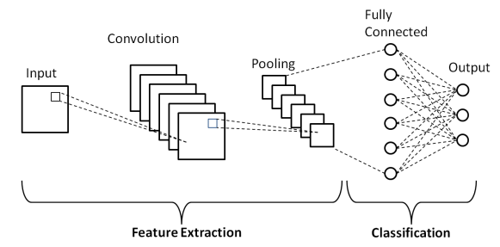

Fig.1 - CNN Architecture

**Training Procedure:**

The designed CNN model is then trained using the preprocessed dataset. During training, the model learns to map the input images to their corresponding fruit or vegetable classes by adjusting its parameters through optimization algorithms like stochastic gradient descent (SGD) or Adam. The training process requires iteratively feeding batches of images into the network, computing the loss between the predicted and actual labels, and updating the model's parameters to minimize this loss. Techniques such as learning rate scheduling and early stopping are employed to optimize convergence and prevent overfitting.

**Hyperparameter Tuning:**

Hyperparameter tuning plays a crucial role in optimizing the performance of the CNN model. Parameters such as learning rate, dropout rate, batch size, and optimizer configurations are thoroughly adjusted and authenticated using techniques like grid search or random search. The goal is to identify the optimal combination of hyperparameters that maximizes the model's accuracy and generalization ability on validation datasets.

**Cross-Validation and Validation Strategies:**

To ensure the robustness of the trained model, cross-validation techniques such as k-fold cross-validation are employed. The dataset is partitioned into multiple subsets, and the model is trained and evaluated iteratively on different combinations of training and validation sets. This helps in assessing the model's stability and generalization performance across diverse data distributions and mitigates the risk of overfitting.

**Interpretation and Analysis:**

Finally, the trained CNN model's predictions are interpreted and analyzed to gain insights into its decision-making process. Techniques such as class activation mapping or feature visualization can highlight the regions of input images that contribute most to the model's predictions, aiding in understanding its behavior. Additionally, ablation studies may be conducted to analyze the impact of dissimilar architectural components and hyperparameters on the model's performance, providing valuable insights for further refinement and optimization.

By following this methodology, researchers and practitioners can develop robust CNN-based models for accurate fruit and vegetable prediction, with applications ranging from agricultural automation to food quality inspection and dietary analysis.

**Materials and Experiments:**

In the context of fruit and vegetable prediction employing Convolutional Neural Networks (CNNs), the materials and experiments are components, encompassing an accurate and systematic course to dataset selection, implementation intricacies, training methodologies, and the application of data augmentation techniques.

**Dataset Selection:**

The dataset selection process constitutes the foundation of the entire experiment, involving the procurement of a diverse array of images portraying an extensive spectrum of fruits and vegetables sourced from various repositories. Emphasis is placed on the comprehensive representation of different classes, encompassing common produce like apples, bananas, and tomatoes, alongside more exotic varieties. To ensure the model's adaptability to real-world scenarios, variations in appearance such as size, color, texture, and ripeness are meticulously considered, with each image meticulously annotated and labeled to facilitate supervised learning.

**Implementation Details:**

Implementation details are paramount in crafting a robust CNN architecture tailored explicitly for fruit and vegetable prediction. The architecture typically integrates multiple convolutional layers coupled with max-pooling layers, facilitating the hierarchical extraction of features from input images. Concurrently, essential components such as activation functions, dropout layers for regularization, and batch normalization are strategically integrated to enhance the model's performance and curb overfitting tendencies. Hyperparameter tuning, inclusive of learning rate, batch size, and optimizer configurations, plays a pivotal role in optimizing model convergence and efficacy.

**Training Process:**

The training process comprises 36 classes containing a variety of fruits and vegetables. The dataset is split into three categories as Training data, Validation data and Testing data of equal ratio to ensure sufficient data for model training and to facilitate robust validation. After splitting the data, select a suitable CNN architecture for the task of fruit and vegetable prediction.

Import the libraries and frameworks required for the project. In this project, we used the Tensorflow framework. Tensorflow is an open source framework used to develop models for various tasks, including natural language processing, image recognition, handwriting recognition, and different computational based simulations such as partial differential equations. Since we need to train the images by considering their features, we are building a neural network consisting of the features that were common in the images. So we are using Keras which is a high-level neural network library that runs on the top of Tensorflow.

After loading the training set and validation set, create a CNN model. CNN(Convolutional Neural Network)is a type of artificial neural network used primarily for image recognition and processing, due to its ability to recognize patterns in images. Build the layers of CNN such as Conv2d, MaxPool2d and Dense layer. Conv2D creates a convolution kernel that is convolved with the layer input over a single spatial (or temporal) dimension to produce a tensor of outputs. In image processing a kernel is a convolution matrix which can be used for blurring, sharpening, embossing, edge detection, and more by doing a convolution between a kernel and an image. The MaxPool2D layer takes the important points from the Conv2D layer. The Flatten layer converts the 2D array into a one dimensional array.

The Dropout Layer is a regularization technique used in CNN to help prevent overfitting. The next layer is the Dense Layer which takes the input from the previous layers and produces the output. Dense layer is a fully, deeply connected neural network layer. It uses the activation function named Softmax converts a vector of values to a probability distribution. These values range between 0 to 1 and sums up to 1. Each vector is handled independently.

After building the layers, fit the training data and validation data. Fit the model for 30 epochs. Epoch is the number of iterations used to train the model for one cycle. In an epoch, we use all of the data exactly once. Then save the trained model for further testing.

Preprocess the test dataset using Keras API. Then load the trained model into the testing file. Create a function that takes the input image and converts it into an array for further predicting the desired result.

**Data Augmentation:**

Augmenting the dataset is a crucial facet of the experimental methodology, aimed at enriching diversity and bolstering the model's resilience. Employing a repertoire of augmentation techniques spanning rotation, scaling, flipping, and cropping, additional training samples are synthesized, broadening the model's exposure to varied scenarios within each class. This serves to mitigate overfitting while enhancing the model's capacity to generalize effectively to unseen data.

**Results:**

The trained model achieved 89.4% accuracy while the validation model achieved 87.7% accuracy. Here is the visualization of the trained model in each epoch:

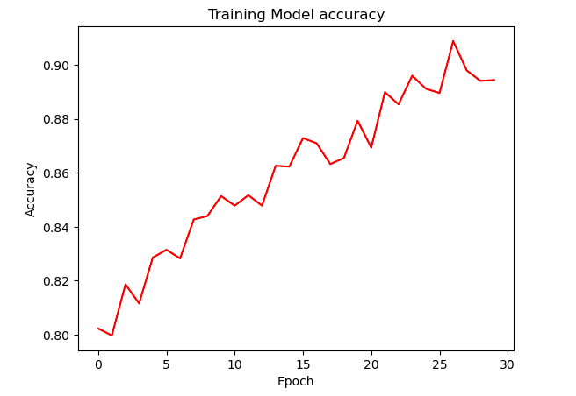

The validation model is visualized as follows:

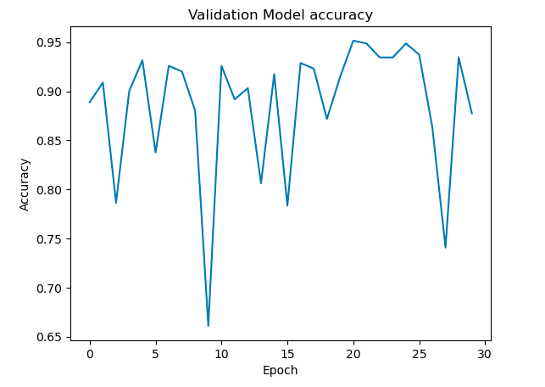

The implementation results are as follows:

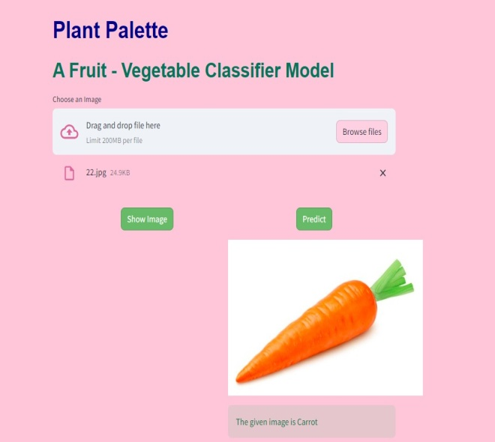

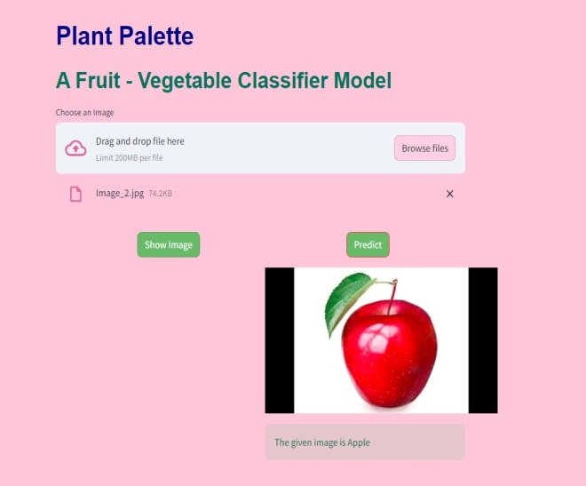

**Conclusion and Future Works:**

We studied 27 different papers and proposed that Deep Learning techniques can be applied to classify fruits and vegetables. Thereby we concluded that Convolutional Neural Network (CNN) is the best suitable algorithm for Fruit and Vegetable Prediction. It is a very crucial function in different fields such as the Food Industry, Agriculture and other industries to predict the quality of fruits and vegetables. We conducted comprehensive Training and Validation procedures for the proposed models, yielding impressive accuracy rates of 87.57% for the Training data and 89.78% for the Validation data. These results underscore the effectiveness of our approach in accurately distinguishing between different types of fruits and vegetables.

The proposed methodology is limited to 36 classes of fruits and vegetables. In the future, we may extend the application by adding a few more classes of fruits and vegetables. Moreover, we aim to explore the potential of utilizing our dataset for other deep learning methods beyond CNNs, particularly in the realms of fruit maturity classification and quality assessment. By investigating alternative algorithms and techniques, we can potentially uncover new insights and further refine our predictive models to better address the dynamic challenges encountered in agricultural automation and food quality inspection.

**References:**

1. Russakovsky, Olga, et al. "Imagenet large scale visual recognition challenge." International journal of computer vision 115 (2015): 211-252.
2. Bargoti, Suchet, and James Underwood. "Deep fruit detection in orchards." 2017 IEEE international conference on robotics and automation (ICRA). IEEE, 2017.
3. Wang, Shuihua, et al. "Fruit classification by wavelet-entropy and feedforward neural network trained by fitness-scaled chaotic ABC and biogeography-based optimization." Entropy 17.8 (2015): 5711-5728.
4. Fan, Shuxiang, et al. "Online detection of defective apples using a computer vision system combined with deep learning methods." Journal of Food Engineering 286 (2020): 110102.
5. Russakovsky, Olga, et al. "Imagenet large scale visual recognition challenge." International journal of computer vision 115 (2015): 211-252.
6. Rizwan Iqbal, Hafiz Muhammad, and Ayesha Hakim. "Classification and grading of harvested mangoes using convolutional neural network." International Journal of Fruit Science 22.1 (2022): 95-109.
7. Seng, Woo Chaw, and Seyed Hadi Mirisaee. "A new method for fruits recognition system." 2009 International conference on electrical engineering and informatics. Vol. 1. IEEE, 2009.
8. Zawbaa, Hossam M., et al. "Automatic fruit classification using random forest algorithm." 2014 14th international conference on hybrid intelligent systems. IEEE, 2014.
9. Zhang, Yu-Dong, et al. "Image based fruit category classification by 13-layer deep convolutional neural network and data augmentation." Multimedia Tools and Applications 78 (2019): 3613-3632.
10. Abi Sen, Adnan Ahmed, et al. "A classification algorithm for date fruits." 2020 7th International Conference on Computing for Sustainable Global Development (INDIACom). IEEE, 2020.
11. Wang, Qi, et al. "Automated crop yield estimation for apple orchards." Experimental robotics: The 13th international symposium on experimental robotics. Springer international publishing, 2013.
12. Bac, C. W., Jochen Hemming, and E.J.Van Henten. "Robust pixel based classification of obstacles for robotic harvesting of sweet-pepper." Computers and electronics in agriculture 96 (2013): 148-162.
13. Song, Y., et al. "Automatic fruit recognition and counting from multiple images." Biosystems Engineering 118 (2014): 203-215.
14. Zhang, Yu-Dong, et al. "Image based fruit category classification by 13 layer deep convolutional neural network and data augmentation." Multimedia Tools and Applications 78 (2019): 3613-3632.
15. Pardo-Mates, Naiara, et al. "Characterization, classification and authentication of fruit-based extracts by means of HPLC-UV chromatographic fingerprints, polyphenolic profiles and chemometric methods".Food chemistry 221 (2017): 29-38.
16. Shao, Wenhao, et al. "Rapid classification of Chinese quince (Chaenomeles speciosa Nakai) fruit provenance by near-infrared spectroscopy and multivariate calibration." Analytical and Bioanalytical Chemistry 409 (2017): 115-120.
17. Ciptohadijoyo, S., et al. "Electronic nose based on a partition column integrated with a gas sensor for fruit identification and classification." Computers and Electronics in Agriculture 121 (2016): 429-435.
18. Fei-Fei, Li, Robert Fergus, and Pietro Perona. "One-shot learning of object categories." IEEE transactions on pattern analysis and machine intelligence 28.4 (2006): 594-611.
19. Al-Masawabe, Marah M., et al. "Papaya Maturity Classifications using Deep Convolutional Neural Networks." (2021).
20. Hao, Jinglei, Yongqiang Zhao, and Qunnie Peng. "A Specular Highlight Removal Algorithm for Quality Inspection of Fresh Fruits." Remote Sensing 14.13 (2022): 3215.
21. Ananthanarayana, Tejaswini, Raymond Ptucha, and Sean C. Kelly. "Deep learning based fruit freshness classification and detection with CMOS image sensors and edge processors." Electronic Imaging 32 (2020): 1-7.
22. Chen, Ming-Chih, Yin-Ting Cheng, and Chun-Yu Liu. "Implementation of a Fruit Quality Classification Application Using an Artificial Intelligence Algorithm." Sensors & Materials 34 (2022).
23. Ni, Jiangong, et al. "Monitoring the change process of banana freshness by GoogLeNet." IEEE Access 8 (2020): 228369-228376.
24. Fan, Shuxiang, et al. "Online detection of defective apples using computer vision combined with deep learning methods." Journal of Food Engineering 286 (2020): 110102.
25. Bhargava, Anuja, and Atul Bansal. "Classification and grading of multiple varieties of apple fruit." Food Analytical Methods 14.7 (2021): 1359-1368.
26. Palakodati, Sai Sudha Sonali, et al. "Fresh and Rotten Fruits Classification Using CNN and Transfer Learning." Rev. d'Intelligence Artif. 34.5 (2020): 617-622.
27. Krizhevsky, Alex, Ilya Sutskever, and Geoffrey E. Hinton. "Imagenet classification with deep convolutional neural networks." Advances in neural information processing systems 25 (2012).